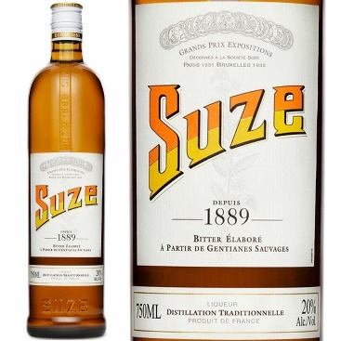

Suze, the Iconic Apéritif from France since 1889!
- Suze was created & launched in 1889 (at the same moment as the Eiffel Tower!)

- Suze is made using 100% Wild French Gentian Roots

- It takes an average of 30 years to grow our wild Gentians!

- We then macerate our Gentian roots for 2 years before going through a distillation process and a final blending with a secret aromatic bouquet

- Suze has been labelled as the “Bartenders’ best Friend” with applications such as the White Negroni, Spritz and pairs especially well with Mezcal & Tequila.

For any question, please contact us at
info@bonnete.com
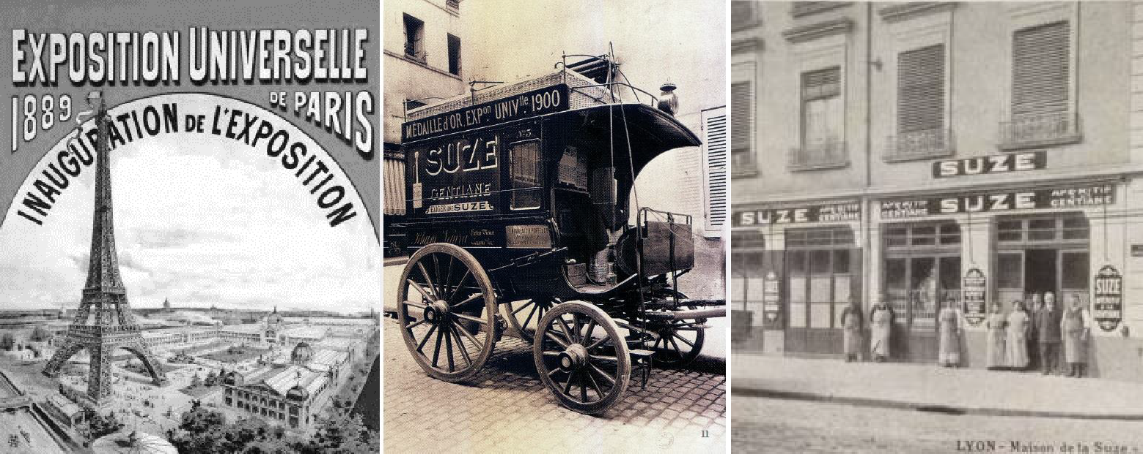
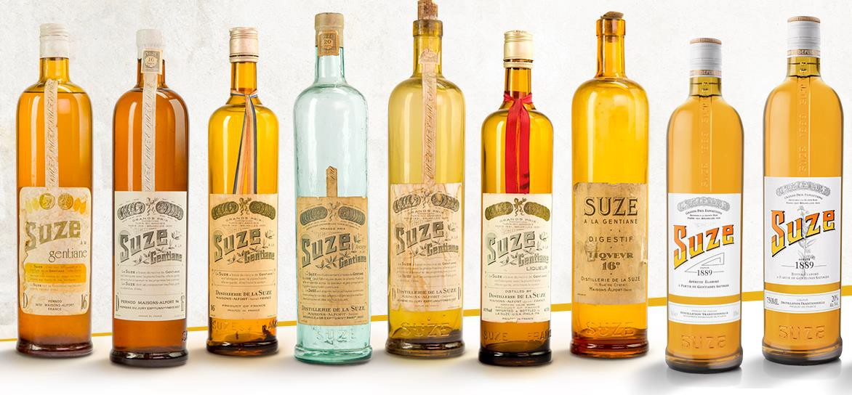
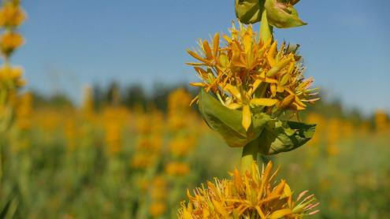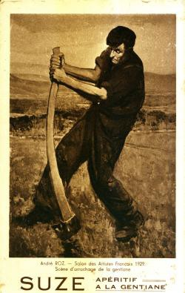
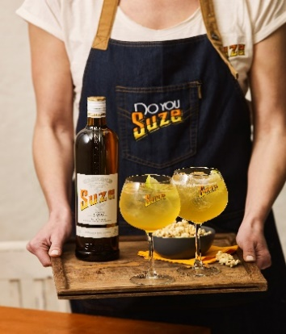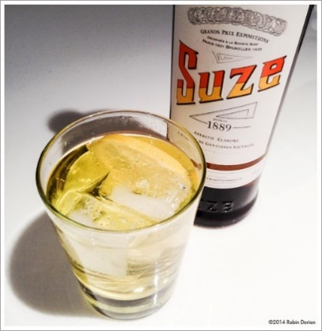
Please visit us at www.bonnete.com

